SANT NANDLAL SMRITI VIDYA MANDIR

Ghatsila



**AISSCE: 2022-2023**

Computer science PROJECT

On

Games mania

NAME - AYAN KUMAR

CLASS - XII Science

ROLL NO. -

CERTIFICATE

**This is to certify that Ayan Kumar of Class XII Science, Roll No. ___________ of Sant Nandlal Smriti Vidya Mandir has successfully completed this project with great satisfactory results under supervisor based on the syllabus of AISSCE 2022-23 examination.**

_____________________ _____________________

**Mr. Saikat Kumar Roy Mrs. N. K. Sinha**

**(HOD, Computer Science) (Principal)**

_________________________

**Signature of External examiner**

ACKNOWLEDGEMENT

I Ayan Kumar of Class XII Science, Roll No. ____________ have completed this investigatory project of computer successfully under the guidance of respected teachers Mr. Saikat Kumar Roy and Mr. Arpa Bhattacharya. Without their help, I couldn’t complete the project on time.

At last but not the least, I would like to expresss my heartiest thanks to my computer teachers who were my consultant and guide. I would also like to acknowledge the support of my parents and friends who had helped me in every step of my project and encouraged me to complete it.

CONTENTS

1. INTRODUCTION

2. LIBRARY MODULES USED AND THEIR PURPOSE

3. SOURCE CODE

4. OUTPUT

5. CONCLUSION

6. BIBLIOGRAPHY

Introduction

Games Menu program is a console application with graphics. This project has multiple types of options and features. First, the main window consists of Login option, and Sign up option. Then in Sign up option, there are many fields for creating a user account. Also, if you forget your password, there is a forgot password option in login page, through which you can change your password by providing your details. After logging in, you will find an interactive menu of different games, from which you can choose any one of them. It also shows you your previous highscore of each game in their respective window as well as the intructions of that particular game. So, with the help of these multiple options you can enjoy playing the game and easily access all the available features of this program. Also, this helps storing the data in an effective way. The project is large complete and I tried my best to make it error free.

It uses following python topics:

* Tkinter
* Functions
* if else
* try except
* sqlite3

Library modules and their purpose

* **import tkinter :-** It is a GUI (Graphical User Interface) which helps and allows us to make programming attractive.
* **from tkinter import ttk :-** A module that is used to style the tjubter widgets.
* **from tkinter import messagebox :-** A module used to display the message boxes in the tkinter.
* **import sqlite3 :-** For database connection.
* **import PIL :-** A module that adds support for opening, manipulating, and saving many different image file formats.
* **import pygame :-** A module designed for writing video games. It includes computer graphics and sound libraries designed to be used with the programming.

SOURCE CODE

import os

import pygame

from pygame.locals import *

from tkinter import *

from tkinter import ttk

from PIL import ImageTk, Image

import tkinter.font as tkFont

from tkinter import messagebox

import sqlite3

mydb = sqlite3.connect("database.db")

mycursor = mydb.cursor()

root = Tk()

root.title("Games Mania")

win_width = 1280

win_height = 720

uservalue = StringVar()

passvalue = StringVar()

new_uservalue = StringVar()

new_mobvalue = StringVar()

new_passvalue = StringVar()

re_passvalue = StringVar()

s_ques = StringVar()

s_ans = StringVar()

font1 = tkFont.Font(family = "Rockwell Extra Bold", size = 40, weight = "bold", underline = 1)

font2 = tkFont.Font(family = "Sans Serif", size = 14, weight = "bold")

font3 = tkFont.Font(family = "Rockwell Extra Bold", size = 20, weight = "bold", underline = 1)

font4 = tkFont.Font(family = "Algerian", size=30, weight = "bold", underline=2)

font5 = tkFont.Font(family = "Algerian", size=20, weight = "bold", underline=2)

font6 = tkFont.Font(family = "Sans Serif", size = 18, weight = "bold")

current_user = ""

logo = Image.open("pictures/logo.jpg")

logo = ImageTk.PhotoImage(logo)

bg0 = Image.open("pictures/menu.png")

bg0 = bg0.resize((win_width-12, win_height-12))

bg0 = ImageTk.PhotoImage(bg0)

bg1 = Image.open("pictures/background.png")

bg1 = bg1.resize((win_width, win_height))

bg1 = ImageTk.PhotoImage(bg1)

bg2 = Image.open("pictures/fruit_fg.jpg")

bg2 = bg2.resize((win_width, win_height))

bg2 = ImageTk.PhotoImage(bg2)

bg3 = Image.open("pictures/tank_fg.jpg")

bg3 = bg3.resize((win_width, win_height))

bg3 = ImageTk.PhotoImage(bg3)

bg4 = Image.open("pictures/car_fg.jpg")

bg4 = bg4.resize((win_width, win_height))

bg4 = ImageTk.PhotoImage(bg4)

root.geometry(f"{win_width}x{win_height}")

root.minsize(win_width, win_height)

root.maxsize(win_width, win_height)

root.iconphoto(False, logo)

def fruit_ninja(who):

import pygame, sys

import os

import random

player_lives = 3

score = 0

fruits = ['melon', 'orange', 'pomegranate', 'guava', 'bomb']

WIDTH = 800

HEIGHT = 500

FPS = 15

pygame.init()

pygame.display.set_caption('Fruit-Ninja Game')

gameDisplay = pygame.display.set_mode((WIDTH, HEIGHT))

clock = pygame.time.Clock()

WHITE = (255,255,255)

BLACK = (0,0,0)

RED = (255,0,0)

GREEN = (0,255,0)

BLUE = (0,0,255)

background = pygame.image.load('back.jpg')

font = pygame.font.Font(os.path.join(os.getcwd(), 'comic.ttf'), 42)

score_text = font.render('Score : ' + str(score), True, (255, 255, 255))

lives_icon = pygame.image.load('images/white_lives.png')

def generate_random_fruits(fruit):

fruit_path = "images/" + fruit + ".png"

data[fruit] = {

'img': pygame.image.load(fruit_path),

'x' : random.randint(100,500),

'y' : 800,

'speed_x': random.randint(-10,10),

'speed_y': random.randint(-80, -60),

'throw': False,

't': 0,

'hit': False,

}

if random.random() >= 0.75:

data[fruit]['throw'] = True

else:

data[fruit]['throw'] = False

data = {}

for fruit in fruits:

generate_random_fruits(fruit)

def hide_cross_lives(x, y):

gameDisplay.blit(pygame.image.load("images/red_lives.png"), (x, y))

font_name = pygame.font.match_font('comic.ttf')

def draw_text(display, text, size, x, y):

font = pygame.font.Font(font_name, size)

text_surface = font.render(text, True, WHITE)

text_rect = text_surface.get_rect()

text_rect.midtop = (x, y)

gameDisplay.blit(text_surface, text_rect)

def draw_lives(display, x, y, lives, image) :

for i in range(lives) :

img = pygame.image.load(image)

img_rect = img.get_rect()

img_rect.x = int(x + 35 * i)

img_rect.y = y

display.blit(img, img_rect)

def show_gameover_screen():

gameDisplay.blit(background, (0,0))

draw_text(gameDisplay, "FRUIT NINJA!", 90, WIDTH / 2, HEIGHT / 4)

if not game_over :

draw_text(gameDisplay,"Score : " + str(score), 50, WIDTH / 2, HEIGHT /2)

draw_text(gameDisplay, "Press a key to begin!", 64, WIDTH / 2, HEIGHT * 3 / 4)

pygame.display.flip()

waiting = True

while waiting:

clock.tick(FPS)

for event in pygame.event.get():

if event.type == pygame.QUIT:

pygame.quit()

return

if event.type == pygame.KEYUP:

waiting = False

first_round = True

game_over = True

game_running = True

mycursor.execute("SELECT * from `user` WHERE username = ?", (who, ))

myresult = mycursor.fetchone()

highscore = myresult[5]

while game_running :

if game_over :

if first_round :

show_gameover_screen()

first_round = False

game_over = False

player_lives = 3

draw_lives(gameDisplay, 690, 5, player_lives, 'images/red_lives.png')

score = 0

for event in pygame.event.get():

if event.type == pygame.QUIT:

game_running = False

gameDisplay.blit(background, (0, 0))

gameDisplay.blit(score_text, (0, 0))

draw_lives(gameDisplay, 690, 5, player_lives, 'images/red_lives.png')

for key, value in data.items():

if value['throw']:

value['x'] += value['speed_x']

value['y'] += value['speed_y']

value['speed_y'] += (1 * value['t'])

value['t'] += 1

if value['y'] <= 800:

gameDisplay.blit(value['img'], (value['x'], value['y']))

else:

generate_random_fruits(key)

current_position = pygame.mouse.get_pos()

if not value['hit'] and current_position[0] > value['x'] and current_position[0] < value['x']+60 \

and current_position[1] > value['y'] and current_position[1] < value['y']+60:

if key == 'bomb':

player_lives -= 1

if player_lives == 0:

hide_cross_lives(690, 15)

elif player_lives == 1 :

hide_cross_lives(725, 15)

elif player_lives == 2 :

hide_cross_lives(760, 15)

if player_lives < 0 :

show_gameover_screen()

game_over = True

half_fruit_path = "images/explosion.png"

else:

half_fruit_path = "images/" + "half_" + key + ".png"

value['img'] = pygame.image.load(half_fruit_path)

value['speed_x'] += 10

if key != 'bomb' :

score += 1

score_text = font.render('Score : ' + str(score), True, (255, 255, 255))

if int(highscore)>int(score):

sql = f"UPDATE `user` SET `fruit-score` = '{highscore}' WHERE `user`.`username` = '{who}'"

mycursor.execute(sql)

mydb.commit()

elif highscore<score:

sql = f"UPDATE `user` SET `fruit-score` = '{score}' WHERE `user`.`username` = '{who}'"

mycursor.execute(sql)

mydb.commit()

value['hit'] = True

else:

generate_random_fruits(key)

pygame.display.update()

clock.tick(FPS)

pygame.quit()

return

def pocket_tanks():

import pygame

import random

pygame.init()

display_width = 800

display_height = 600

game_layout_display = pygame.display.set_mode((display_width, display_height))

pygame.display.set_caption('Tanks Game')

Resources = pygame.image.load("game_background.png")

pygame.display.set_icon(Resources)

wheat = (245, 222, 179)

white = (255, 255, 255)

black = (0, 0, 0)

blue = (0, 0, 255)

red = (200, 0, 0)

light_red = (255, 0, 0)

yellow = (200, 200, 0)

light_yellow = (255, 255, 0)

green = (34, 177, 76)

light_green = (0, 255, 0)

clock = pygame.time.Clock()

tnk_width = 40

tnk_height = 20

tur_width = 5

whl_width = 5

grnd_height = 35

s_font = pygame.font.SysFont("Times New Roman", 25)

m_font = pygame.font.SysFont("Times New Roman", 50)

l_font = pygame.font.SysFont("Times New Roman", 85)

vs_font = pygame.font.SysFont("Times New Roman", 25)

def Score(Score):

txt = s_font.render("Score: " + str(Score), True, white)

game_layout_display.blit(txt, [0, 0])

def txt_object(txt, color, size="small"):

if size == "small":

txtSrfc = s_font.render(txt, True, color)

if size == "medium":

txtSrfc = m_font.render(txt, True, color)

if size == "large":

txtSrfc = l_font.render(txt, True, color)

if size == "vsmall":

txtSrfc = vs_font.render(txt, True, color)

return txtSrfc, txtSrfc.get_rect()

def txt_btn(message, color, btnx, btny, btnwidth, btnheight, size="vsmall"):

txtSrf, textRect = txt_object(message, color, size)

textRect.center = ((btnx + (btnwidth / 2)), btny + (btnheight / 2))

game_layout_display.blit(txtSrf, textRect)

def msg_screen(message, color, y_displace=0, size="small"):

txtSrf, textRect = txt_object(message, color, size)

textRect.center = (int(display_width / 2), int(display_height / 2) + y_displace)

game_layout_display.blit(txtSrf, textRect)

def tank(x, y, turret_position):

x = int(x)

y = int(y)

pos_Turrets = [(x - 27, y - 2),

(x - 26, y - 5),

(x - 25, y - 8),

(x - 23, y - 12),

(x - 20, y - 14),

(x - 18, y - 15),

(x - 15, y - 17),

(x - 13, y - 19),

(x - 11, y - 21)

]

pygame.draw.circle(game_layout_display, blue, (x, y), int(tnk_height / 2))

pygame.draw.rect(game_layout_display, blue, (x - tnk_height, y, tnk_width, tnk_height))

pygame.draw.line(game_layout_display, blue, (x, y), pos_Turrets[turret_position], tur_width)

pygame.draw.circle(game_layout_display, blue, (x - 15, y + 20), whl_width)

pygame.draw.circle(game_layout_display, blue, (x - 10, y + 20), whl_width)

pygame.draw.circle(game_layout_display, blue, (x - 15, y + 20), whl_width)

pygame.draw.circle(game_layout_display, blue, (x - 10, y + 20), whl_width)

pygame.draw.circle(game_layout_display, blue, (x - 5, y + 20), whl_width)

pygame.draw.circle(game_layout_display, blue, (x, y + 20), whl_width)

pygame.draw.circle(game_layout_display, blue, (x + 5, y + 20), whl_width)

pygame.draw.circle(game_layout_display, blue, (x + 10, y + 20), whl_width)

pygame.draw.circle(game_layout_display, blue, (x + 15, y + 20), whl_width)

return pos_Turrets[turret_position]

def computer_tank(x, y, turret_position):

x = int(x)

y = int(y)

pos_Turrets = [(x + 27, y - 2),

(x + 26, y - 5),

(x + 25, y - 8),

(x + 23, y - 12),

(x + 20, y - 14),

(x + 18, y - 15),

(x + 15, y - 17),

(x + 13, y - 19),

(x + 11, y - 21)

]

pygame.draw.circle(game_layout_display, blue, (x, y), int(tnk_height / 2))

pygame.draw.rect(game_layout_display, blue, (x - tnk_height, y, tnk_width, tnk_height))

pygame.draw.line(game_layout_display, blue, (x, y), pos_Turrets[turret_position], tur_width)

pygame.draw.circle(game_layout_display, blue, (x - 15, y + 20), whl_width)

pygame.draw.circle(game_layout_display, blue, (x - 10, y + 20), whl_width)

pygame.draw.circle(game_layout_display, blue, (x - 15, y + 20), whl_width)

pygame.draw.circle(game_layout_display, blue, (x - 10, y + 20), whl_width)

pygame.draw.circle(game_layout_display, blue, (x - 5, y + 20), whl_width)

pygame.draw.circle(game_layout_display, blue, (x, y + 20), whl_width)

pygame.draw.circle(game_layout_display, blue, (x + 5, y + 20), whl_width)

pygame.draw.circle(game_layout_display, blue, (x + 10, y + 20), whl_width)

pygame.draw.circle(game_layout_display, blue, (x + 15, y + 20), whl_width)

return pos_Turrets[turret_position]

def game_ctrls():

gameControl = True

while gameControl:

for event in pygame.event.get():

if event.type == pygame.QUIT:

pygame.quit()

game_layout_display.fill(black)

msg_screen("Controls", white, -100, size="large")

msg_screen("Fire: Spacebar", wheat, -30)

msg_screen("Move Turret: Up and Down arrows", wheat, 10)

msg_screen("Move Tank: Left and Right arrows", wheat, 50)

msg_screen("Press D to raise Power % AND Press A to lower Power % ", wheat, 140)

msg_screen("Pause: P", wheat, 90)

btn("Play", 150, 500, 100, 50, green, light_green, action="play")

btn("Main", 350, 500, 100, 50, yellow, light_yellow, action="main")

btn("Quit", 550, 500, 100, 50, red, light_red, action="quit")

pygame.display.update()

clock.tick(15)

def btn(txt, x, y, width, height, inactive_color, active_color, action=None,size=" "):

cursor = pygame.mouse.get_pos()

click = pygame.mouse.get_pressed()

if x + width > cursor[0] > x and y + height > cursor[1] > y:

pygame.draw.rect(game_layout_display, active_color, (x, y, width, height))

if click[0] == 1 and action != None:

if action == "quit":

pygame.quit()

if action == "controls":

game_ctrls()

if action == "play":

gameLoop()

if action == "main":

game_intro()

else:

pygame.draw.rect(game_layout_display, inactive_color, (x, y, width, height))

txt_btn(txt, black, x, y, width, height)

def pause():

paused = True

msg_screen("Paused", white, -100, size="large")

msg_screen("Press C to continue playing or Q to quit", wheat, 25)

pygame.display.update()

while paused:

for event in pygame.event.get():

if event.type == pygame.QUIT:

pygame.quit()

if event.type == pygame.KEYDOWN:

if event.key == pygame.K_c:

paused = False

elif event.key == pygame.K_q:

pygame.quit()

clock.tick(5)

def barrier(x_loc, ran_height, bar_width):

pygame.draw.rect(game_layout_display, green, [x_loc, display_height - ran_height, bar_width, ran_height])

def explosion(x, y, size=50):

exp = True

while exp:

for event in pygame.event.get():

if event.type == pygame.QUIT:

pygame.quit()

startPoint = x, y

choice_colors = [red, light_red, yellow, light_yellow]

mgntde = 1

while mgntde < size:

exploding_bit_x = x + random.randrange(-1 * mgntde, mgntde)

exploding_bit_y = y + random.randrange(-1 * mgntde, mgntde)

pygame.draw.circle(game_layout_display, choice_colors[random.randrange(0, 4)], (exploding_bit_x, exploding_bit_y),

random.randrange(1, 5))

mgntde += 1

pygame.display.update()

clock.tick(100)

exp = False

def playerfireShell(xy, tankx, tanky, turPost, gun_power, xloc, bar_width, ranHeight, eTankX, eTankY):

fire = True

damage = 0

startShell = list(xy)

print("FIRE!", xy)

while fire:

for event in pygame.event.get():

if event.type == pygame.QUIT:

pygame.quit()

pygame.draw.circle(game_layout_display, red, (startShell[0], startShell[1]), 5)

startShell[0] -= (12 - turPost) * 2

startShell[1] += int(

(((startShell[0] - xy[0]) * 0.015 / (gun_power / 50)) ** 2) - (turPost + turPost / (12 - turPost)))

if startShell[1] > display_height - grnd_height:

print("Last shell:", startShell[0], startShell[1])

hit_x = int((startShell[0] * display_height - grnd_height) / startShell[1])

hit_y = int(display_height - grnd_height)

print("Impact:", hit_x, hit_y)

if eTankX + 10 > hit_x > eTankX - 10:

print("Critical Hit!")

damage = 25

elif eTankX + 15 > hit_x > eTankX - 15:

print("Hard Hit!")

damage = 18

elif eTankX + 25 > hit_x > eTankX - 25:

print("Medium Hit")

damage = 10

elif eTankX + 35 > hit_x > eTankX - 35:

print("Light Hit")

damage = 5

explosion(hit_x, hit_y)

fire = False

check_x_1 = startShell[0] <= xloc + bar_width

check_x_2 = startShell[0] >= xloc

check_y_1 = startShell[1] <= display_height

check_y_2 = startShell[1] >= display_height - ranHeight

if check_x_1 and check_x_2 and check_y_1 and check_y_2:

print("Last shell:", startShell[0], startShell[1])

hit_x = int((startShell[0]))

hit_y = int(startShell[1])

print("Impact:", hit_x, hit_y)

explosion(hit_x, hit_y)

fire = False

pygame.display.update()

clock.tick(60)

return damage

def computerfireShell(xy, tankx, tanky, turPost, gun_power, xloc, bar_width, ranHeight, ptankx, ptanky):

damage = 0

cPower = 1

pow_found = False

while not pow_found:

cPower += 1

if cPower > 100:

pow_found = True

fire = True

startShell = list(xy)

while fire:

for event in pygame.event.get():

if event.type == pygame.QUIT:

pygame.quit()

startShell[0] += (12 - turPost) * 2

startShell[1] += int(

(((startShell[0] - xy[0]) * 0.015 / (cPower / 50)) ** 2) - (turPost + turPost / (12 - turPost)))

if startShell[1] > display_height - grnd_height:

hit_x = int((startShell[0] * display_height - grnd_height) / startShell[1])

hit_y = int(display_height - grnd_height)

if ptankx + 15 > hit_x > ptankx - 15:

print("target acquired!")

pow_found = True

fire = False

check_x_1 = startShell[0] <= xloc + bar_width

check_x_2 = startShell[0] >= xloc

check_y_1 = startShell[1] <= display_height

check_y_2 = startShell[1] >= display_height - ranHeight

if check_x_1 and check_x_2 and check_y_1 and check_y_2:

hit_x = int((startShell[0]))

hit_y = int(startShell[1])

fire = False

fire = True

startShell = list(xy)

print("FIRE!", xy)

while fire:

for event in pygame.event.get():

if event.type == pygame.QUIT:

pygame.quit()

pygame.draw.circle(game_layout_display, red, (startShell[0], startShell[1]), 5)

startShell[0] += (12 - turPost) * 2

gun_power = random.randrange(int(cPower * 0.90), int(cPower * 1.10))

startShell[1] += int(

(((startShell[0] - xy[0]) * 0.015 / (gun_power / 50)) ** 2) - (turPost + turPost / (12 - turPost)))

if startShell[1] > display_height - grnd_height:

print("last shell:", startShell[0], startShell[1])

hit_x = int((startShell[0] * display_height - grnd_height) / startShell[1])

hit_y = int(display_height - grnd_height)

print("Impact:", hit_x, hit_y)

if ptankx + 10 > hit_x > ptankx - 10:

print("Critical Hit!")

damage = 25

elif ptankx + 15 > hit_x > ptankx - 15:

print("Hard Hit!")

damage = 18

elif ptankx + 25 > hit_x > ptankx - 25:

print("Medium Hit")

damage = 10

elif ptankx + 35 > hit_x > ptankx - 35:

print("Light Hit")

damage = 5

explosion(hit_x, hit_y)

fire = False

check_x_1 = startShell[0] <= xloc + bar_width

check_x_2 = startShell[0] >= xloc

check_y_1 = startShell[1] <= display_height

check_y_2 = startShell[1] >= display_height - ranHeight

if check_x_1 and check_x_2 and check_y_1 and check_y_2:

print("Last shell:", startShell[0], startShell[1])

hit_x = int((startShell[0]))

hit_y = int(startShell[1])

print("Impact:", hit_x, hit_y)

explosion(hit_x, hit_y)

fire = False

pygame.display.update()

clock.tick(60)

return damage

def power(level):

text = s_font.render("Power: " + str(level) + "%", True, wheat)

game_layout_display.blit(text, [display_width / 2, 0])

def game_intro():

intro = True

while intro:

for event in pygame.event.get():

if event.type == pygame.QUIT:

pygame.quit()

if event.type == pygame.KEYDOWN:

if event.key == pygame.K_c:

intro = False

elif event.key == pygame.K_q:

pygame.quit()

game_layout_display.fill(black)

msg_screen("Welcome to Tanks War!", white, -100, size="large")

msg_screen("The goal is to shoot and destroy", wheat, 15)

msg_screen("the enemy tank before they destroy you.", wheat, 60)

msg_screen("The more enemies you destroy, the highest score you get.", wheat, 110)

msg_screen("Enjoy Playing", wheat, 280)

btn("Play", 150, 500, 100, 50, wheat, light_green, action="play",size="vsmall")

btn("Controls", 350, 500, 100, 50, wheat, light_yellow, action="controls",size="vsmall")

btn("Quit", 550, 500, 100, 50, wheat, light_red, action="quit",size="vsmall")

pygame.display.update()

clock.tick(15)

def game_over():

game_over = True

while game_over:

for event in pygame.event.get():

if event.type == pygame.QUIT:

pygame.quit()

game_layout_display.fill(black)

msg_screen("Game Over", white, -100, size="large")

msg_screen("You died.", wheat, -30)

btn("Play Again", 150, 500, 150, 50, wheat, light_green, action="play")

btn("Controls", 350, 500, 100, 50, wheat, light_yellow, action="controls")

btn("Quit", 550, 500, 100, 50, wheat, light_red, action="quit")

pygame.display.update()

clock.tick(15)

def you_win():

win = True

while win:

for event in pygame.event.get():

if event.type == pygame.QUIT:

pygame.quit()

game_layout_display.fill(black)

msg_screen("You won!", white, -100, size="large")

msg_screen("Congratulations!", wheat, -30)

btn("play Again", 150, 500, 150, 50, wheat, light_green, action="play")

btn("controls", 350, 500, 100, 50, wheat, light_yellow, action="controls")

btn("quit", 550, 500, 100, 50, wheat, light_red, action="quit")

pygame.display.update()

clock.tick(15)

def health_bars(p_health, e_health):

if p_health > 75:

p_health_color = green

elif p_health > 50:

p_health_color = yellow

else:

p_health_color = red

if e_health > 75:

e_health_color = green

elif e_health > 50:

e_health_color = yellow

else:

e_health_color = red

pygame.draw.rect(game_layout_display, p_health_color, (680, 25, p_health, 25))

pygame.draw.rect(game_layout_display, e_health_color, (20, 25, e_health, 25))

def gameLoop():

gExit = False

gOver = False

FPS = 15

p_health = 100

e_health = 100

bar_width = 50

mTankX = display_width * 0.9

mTankY = display_height * 0.9

tnkMove = 0

curTurPost = 0

changeTurs = 0

eTankX = display_width * 0.1

eTankY = display_height * 0.9

f_power = 50

p_change = 0

xloc = (display_width / 2) + random.randint(-0.1 * display_width, 0.1 * display_width)

ranHeight = random.randrange(display_height * 0.1, display_height * 0.6)

while not gExit:

if gOver == True:

msg_screen("Game Over", red, -50, size="large")

msg_screen("Press C to play again or Q to exit", black, 50)

pygame.display.update()

while gOver == True:

for event in pygame.event.get():

if event.type == pygame.QUIT:

gExit = True

gOver = False

if event.type == pygame.KEYDOWN:

if event.key == pygame.K_c:

gameLoop()

elif event.key == pygame.K_q:

gExit = True

gOver = False

for event in pygame.event.get():

if event.type == pygame.QUIT:

gExit = True

if event.type == pygame.KEYDOWN:

if event.key == pygame.K_LEFT:

tnkMove = -5

elif event.key == pygame.K_RIGHT:

tnkMove = 5

elif event.key == pygame.K_UP:

changeTurs = 1

elif event.key == pygame.K_DOWN:

changeTurs= -1

elif event.key == pygame.K_p:

pause()

elif event.key == pygame.K_SPACE:

damage = playerfireShell(gun, mTankX, mTankY, curTurPost, f_power, xloc, bar_width,

ranHeight, eTankX, eTankY)

e_health -= damage

posMovement = ['f', 'r']

moveInd = random.randrange(0, 2)

for x in range(random.randrange(0, 10)):

if display_width * 0.3 > eTankX > display_width * 0.03:

if posMovement[moveInd] == "f":

eTankX += 5

elif posMovement[moveInd] == "r":

eTankX -= 5

game_layout_display.fill(black)

health_bars(p_health, e_health)

gun = tank(mTankX, mTankY, curTurPost)

e_gun = computer_tank(eTankX, eTankY, 8)

f_power += p_change

power(f_power)

barrier(xloc, ranHeight, bar_width)

game_layout_display.fill(green,

rect=[0, display_height - grnd_height, display_width, grnd_height])

pygame.display.update()

clock.tick(FPS)

damage = computerfireShell(e_gun, eTankX, eTankY, 8, 50, xloc, bar_width,

ranHeight, mTankX, mTankY)

p_health -= damage

elif event.key == pygame.K_a:

p_change = -1

elif event.key == pygame.K_d:

p_change = 1

elif event.type == pygame.KEYUP:

if event.key == pygame.K_LEFT or event.key == pygame.K_RIGHT:

tnkMove = 0

if event.key == pygame.K_UP or event.key == pygame.K_DOWN:

changeTurs = 0

if event.key == pygame.K_a or event.key == pygame.K_d:

p_change = 0

mTankX += tnkMove

curTurPost += changeTurs

if curTurPost > 8:

curTurPost = 8

elif curTurPost < 0:

curTurPost = 0

if mTankX - (tnk_width / 2) < xloc + bar_width:

mTankX += 5

game_layout_display.fill(black)

health_bars(p_health, e_health)

gun = tank(mTankX, mTankY, curTurPost)

e_gun = computer_tank(eTankX, eTankY, 8)

f_power += p_change

if f_power > 100:

f_power = 100

elif f_power < 1:

f_power = 1

power(f_power)

barrier(xloc, ranHeight, bar_width)

game_layout_display.fill(green, rect=[0, display_height - grnd_height, display_width, grnd_height])

pygame.display.update()

if p_health < 1:

game_over()

elif e_health < 1:

you_win()

clock.tick(FPS)

pygame.quit()

return

game_intro()

gameLoop()

def car_racing(who):

import pygame

import time

import random

import os

pygame.init()

screen_width = 400

screen_height = 600

btn_starting_x = 75

nw_gm_y = 400

exit_y = 460

btn_width = 242

btn_height = 50

black_color = (0, 0, 0)

white_color = (255, 255, 255)

red_color = (255, 0, 0)

redLight_color = (255, 21, 21)

gray_color = (112, 128, 144)

green_color = (0, 255, 0)

greenLight_color = (51, 255, 51)

blue_color = (0, 0, 255)

game_layout_display= pygame.display.set_mode((screen_width, screen_height))

pygame.display.set_caption('F1 Race Road Game')

time_clock=pygame.time.Clock()

car_photo = pygame.image.load(os.getcwd() + '\\images/car.png')

left_c = pygame.image.load(os.getcwd() + '\\images/car_left.png')

right_c = pygame.image.load(os.getcwd() + '\\images/car_right.png')

photo_obstacle = pygame.image.load(os.getcwd() + '\\images/obstacle.png')

texture_photo = pygame.image.load(os.getcwd() + '\\images/texture.png')

(c_width, c_height) = car_photo.get_rect().size

(c_left_width, c_left_height) = left_c.get_rect().size

(c_right_width, c_right_height) = right_c.get_rect().size

(t_width, t_height) = photo_obstacle.get_rect().size

(txtwidth, txtheight) = texture_photo.get_rect().size

icon = pygame.image.load(os.getcwd() + '\\images/logo.png')

pygame.display.set_icon(icon)

image_background = pygame.image.load(os.getcwd() + '\\images/background.png')

image_background_still = pygame.image.load(os.getcwd() + '\\images/background_inv.png')

bckgrndRect = image_background.get_rect()

#welcome_1 = pygame.mixer.Sound(os.getcwd() + '\\audio/intro1.wav')

#welcome_2 = pygame.mixer.Sound(os.getcwd() + '\\audio/intro2.wav')

#audio_crash = pygame.mixer.Sound(os.getcwd() + '\\audio/car_crash.wav')

#audio_ignition = pygame.mixer.Sound(os.getcwd() + '\\audio/ignition.wav')

#pygame.mixer.music.load(os.getcwd()+'\\audio/running.wav')

def things_dodged(counting, highest_score, everything_speed):

fnt = pygame.font.SysFont(None, 25)

score = fnt.render("Dodged: " + str(counting), True, green_color)

h_score = fnt.render("High Score: " + str(highest_score), True, green_color)

speed = fnt.render("Speed: " + str(everything_speed) + "Km/h", True, green_color)

game_layout_display.blit(score, (10, 0))

game_layout_display.blit(h_score, (10, 27))

game_layout_display.blit(speed, (screen_width - 125, 0))

def high_score_update(dodged):

high_scores = open(os.getcwd()+'\\textfile/high_score.txt', 'w')

temperd = str(dodged)

high_scores.write(temperd)

def things(th_x, th_y):

game_layout_display.blit(photo_obstacle, (th_x, th_y))

def car(x, y, direction):

if direction==0:

game_layout_display.blit(car_photo, (x, y))

if direction==-1:

game_layout_display.blit(left_c, (x, y))

if direction==1:

game_layout_display.blit(right_c, (x, y))

def text_objects(text, font, color):

txtSurf = font.render(text, True, color)

return txtSurf, txtSurf.get_rect()

def message_display_screen(txt, sh_x, sh_y, color, time_sleeping):

lar_txt = pygame.font.Font('freesansbold.ttf',50)

txtSurf, TxtRect = text_objects(txt, lar_txt, color)

TxtRect.center = ((screen_width / 2 - sh_x), (screen_height / 2 - sh_y))

game_layout_display.blit(txtSurf, TxtRect)

pygame.display.update()

time.sleep(time_sleeping)

def title_message_display(sh_x, sh_y, color):

lar_txt = pygame.font.Font('freesansbold.ttf',60)

txtSurf, TxtRect = text_objects("F1 RaceRoad", lar_txt, color)

TxtRect.center = ((screen_width / 2 - sh_x), (screen_height / 3 - sh_y))

game_layout_display.blit(txtSurf, TxtRect)

time.sleep(0.15)

pygame.display.update()

def title_msg():

animation_height=screen_height

#pygame.mixer.Sound.play(welcome_1)

while animation_height > -600:

game_layout_display.fill(white_color)

things(screen_width / 2 - t_width / 2, animation_height)

animation_height-=1.5

pygame.display.update()

title_message_display(0, 0, black_color)

time.sleep(0.1)

#pygame.mixer.Sound.play(welcome_2)

def motion_texture(th_starting):

game_layout_display.blit(texture_photo, (0, th_starting - 400))

game_layout_display.blit(texture_photo, (0, th_starting))

game_layout_display.blit(texture_photo, (0, th_starting + 400))

def crash_function():

#pygame.mixer.music.stop()

#pygame.mixer.Sound.play(audio_crash)

message_display_screen("YOU CRASHED", 0, 0, red_color, 0)

while True:

playAgain = button("Play Again", btn_starting_x, nw_gm_y, btn_width, btn_height, greenLight_color, green_color)

exit_game = button("Quit", btn_starting_x, exit_y, btn_width, btn_height, redLight_color, red_color)

for event in pygame.event.get():

if event.type == pygame.QUIT or exit_game == 1 or (event.type == pygame.KEYDOWN and event.key == pygame.K_ESCAPE):

pygame.quit()

return

if playAgain== 1 or (event.type == pygame.KEYDOWN and event.key == pygame.K_SPACE):

looping_gameplay()

pygame.display.update()

time_clock.tick(15)

def button(messages, x, y, wid, hei, in_act_color, act_color, action=None):

mouse = pygame.mouse.get_pos()

click = pygame.mouse.get_pressed()

if x + wid > mouse[0] > x and y+hei > mouse[1] > y:

pygame.draw.rect(game_layout_display, act_color, (x, y, wid, hei))

if click[0] == 1:

return 1

else:

pygame.draw.rect(game_layout_display, in_act_color, (x, y, wid, hei))

small_txt = pygame.font.Font('freesansbold.ttf',20)

TxtSurf, TxtRect = text_objects(messages, small_txt, white_color)

TxtRect.center = ((x + wid / 2), (y + hei / 2))

game_layout_display.blit(TxtSurf, TxtRect)

def welcome_gameplay():

welcome = True

game_layout_display.fill(white_color)

title_msg()

exit_game=0

while welcome:

for event in pygame.event.get():

if event.type == pygame.QUIT or exit_game == 1 or (event.type == pygame.KEYDOWN and event.key == pygame.K_ESCAPE):

pygame.quit()

playGame = button("New game", btn_starting_x, nw_gm_y, btn_width, btn_height, greenLight_color, green_color)

exit_game = button("Quit", btn_starting_x, exit_y, btn_width, btn_height, redLight_color, red_color)

if event.type == pygame.KEYDOWN:

if event.key == pygame.K_ESCAPE:

exit_game = 1

if playGame or (event.type == pygame.KEYDOWN and event.key == pygame.K_SPACE):

welcome = False

pygame.display.update()

time_clock.tick(15)

def counting_three_two_one():

counting = 3

#pygame.mixer.music.pause()

#pygame.mixer.Sound.play(audio_ignition)

while counting >= 0:

game_layout_display.blit(image_background, bckgrndRect)

car(screen_width * 0.40, screen_height * 0.6, 0)

if counting == 0:

message_display_screen ("GO!", 0, 0, green_color, 0.75)

#pygame.mixer.music.play(-1)

else:

message_display_screen (str(counting), 0, 0, red_color, 0.75)

counting -= 1

time_clock.tick(15)

def gameplay_paused():

#pygame.mixer.music.pause()

pause = True

while pause:

for event in pygame.event.get():

if event.type == pygame.QUIT or (event.type == pygame.KEYDOWN and event.key == pygame.K_ESCAPE): ###############or quit_game == 1

pygame.quit()

message_display_screen("pause", 0, 0, blue_color, 1.5)

if event.type == pygame.KEYDOWN:

if event.key == pygame.K_SPACE:

#pygame.mixer.music.unpause()

return

pygame.display.update()

time_clock.tick(15)

def looping_gameplay():

#pygame.mixer.music.play(-1)

display = 0

width_x=(screen_width * 0.4)

height_y=(screen_height * 0.6)

ch_x=0

th_st_x = random.randrange(8, screen_width - t_width - 8)

th_st_y = -600

th_speed = 5

tracking_y = 0

tracking_speed = 25

dodg=0

direction = 0

highest_score_txtfile = open(os.getcwd()+'/textfile/high_score.txt','r')

high_score = highest_score_txtfile.read()

gameExit = False

counting_three_two_one()

mycursor.execute("SELECT * from `user` WHERE username = ?", (who, ))

myresult = mycursor.fetchone()

Highscore = myresult[6]

while not gameExit:

for event in pygame.event.get():

if event.type == pygame.QUIT or (event.type == pygame.KEYDOWN and event.key == pygame.K_ESCAPE):

pygame.quit()

if event.type == pygame.KEYDOWN:

if event.key == pygame.K_LEFT or event.key == pygame.K_a:

ch_x = -10

direction = -1

if event.key == pygame.K_RIGHT or event.key == pygame.K_d:

ch_x = 10

direction = 1

if event.key == pygame.K_SPACE:

gameplay_paused()

if event.type == pygame.KEYUP:

if event.key == pygame.K_LEFT or event.key == pygame.K_RIGHT or event.key == pygame.K_a or event.key == pygame.K_d:

ch_x = 0

direction = 0

width_x+=ch_x

game_layout_display.blit(image_background, bckgrndRect)

motion_texture(th_st_y)

things(th_st_x, th_st_y)

th_st_y += th_speed

car(width_x,height_y,direction)

things_dodged(dodg, high_score, th_speed)

if width_x > screen_width - c_width or width_x < 0:

crash_function()

if th_st_y > screen_height:

th_st_y = 0 - t_height

th_st_x = random.randrange(0, screen_width)

dodg += 1

th_speed += 1

if Highscore>dodg:

sql = f"UPDATE `user` SET `car-score` = '{Highscore}' WHERE `user`.`username` = '{who}'"

mycursor.execute(sql)

mydb.commit()

elif Highscore<dodg:

sql = f"UPDATE `user` SET `car-score` = '{dodg}' WHERE `user`.`username` = '{who}'"

mycursor.execute(sql)

mydb.commit()

if dodg > int(high_score):

high_score_update(dodg)

if height_y < th_st_y+t_height-15 and width_x > th_st_x-c_width-5 and width_x < th_st_x+t_width-5:

crash_function()

pygame.display.update()

time_clock.tick(60)

welcome_gameplay()

looping_gameplay()

pygame.quit()

return

def hide_widget(*Widget):

for item in Widget:

item.place_forget()

def show_widget(*Widget):

for item in Widget:

item.place(anchor = "c", relx = 0.5, rely = 0.5)

def clear_entry(*boxes):

for item in boxes:

item.delete(0, END)

def appear_register(widget1, widget2, canvas):

global change_button, change_text, change_message

hide_widget(widget1)

show_widget(widget2)

canvas.delete(change_button, change_text, change_message)

change_text = canvas.create_text(640, 160, text = "REGISTER", fill="#00FFFF", font = font3)

change_message = canvas.create_text(650, 550, text = "Have account? ", fill="#00FFFF", font = font2)

change_button = canvas.create_window(860, 550, window = Button(canvas, text = "Login", font = font2, bg = "#FFFF00", command = lambda : appear_login(login_box, register_box, canvas)))

def appear_login(widget1, widget2, canvas):

global change_button, change_text, change_message

hide_widget(widget2)

show_widget(widget1)

canvas.delete(change_button, change_text, change_message)

change_text = canvas.create_text(640, 200, text = "LOGIN", fill="#00FFFF", font = font3)

change_message = canvas.create_text(700, 500, text = "New user ?", fill="#00FFFF", font = font2)

change_button = canvas.create_window(840, 500, window = Button(canvas, text = "Sign Up", font = font2, bg = "#FFFF00", command = lambda : appear_register(login_box, register_box, canvas)))

def register():

global current_user

user, phn, pas, re_pass, sq, sa = new_userentry.get().strip(), new_mobentry.get().strip(), new_passentry.get().strip(), re_passentry.get().strip(), s_ques.get(), s_ans.get().upper()

invalid_register.grid_forget()

if user and phn and pas and re_pass:

if pas != re_pass:

invalid_register.grid(row = 2, column = 2)

return

else:

if s_ans != "":

sql = "SELECT username FROM user"

mycursor.execute(sql)

myresult = mycursor.fetchall()

result = [i[0] for i in myresult]

if user not in result:

sql = "INSERT INTO user (username, phone, password, squestion, sanswer) VALUES (?, ?, ?, ?, ?)"

val = (user, int(phn), pas, sq, sa)

mycursor.execute(sql, val)

mydb.commit()

current_user = user

menu()

else:

invalid_register.grid(row = 0, column = 2)

else:

invalid_register.grid(row = 4, column = 2)

else:

invalid_register.grid(row = 0, column = 2)

clear_entry(new_userentry, new_mobentry, new_passentry, re_passentry)

def login():

global current_user

invalid_user.grid_forget()

user, pas = userentry.get().strip(), passentry.get().strip()

if user and pas:

sql = "SELECT username, password FROM user"

mycursor.execute(sql)

myresult = mycursor.fetchall()

userlist = [i[0] for i in myresult]

passwordlist = [i[1] for i in myresult]

if user in userlist:

index = userlist.index(user)

if pas == passwordlist[index]:

current_user = user

menu()

else:

invalid_user.grid(row = 1, column = 2)

elif user=="admin" and pas=="12345":

import tkinter as tk

from PIL import ImageTk, Image

my_w = tk.Tk()

my_w.title("Admin Panel")

my_w.geometry("400x250")

my_w['bg']="#00FF00"

e=Label(my_w,width=15,text='Username',borderwidth=2, relief='ridge',anchor='w',bg='#FFFF00', fg="#FF0000")

e.grid(row=0,column=0)

e=Label(my_w,width=15,text='Password',borderwidth=2, relief='ridge',anchor='w',bg='#FFFF00', fg="#FF0000")

e.grid(row=0,column=1)

e=Label(my_w,width=15,text='Mobile No.',borderwidth=2, relief='ridge',anchor='w',bg='#FFFF00', fg="#FF0000")

e.grid(row=0,column=2)

e=Label(my_w,width=15,text='Question',borderwidth=2, relief='ridge',anchor='w',bg='#FFFF00', fg="#FF0000")

e.grid(row=0,column=3)

e=Label(my_w,width=15,text='Answer',borderwidth=2, relief='ridge',anchor='w',bg='#FFFF00', fg="#FF0000")

e.grid(row=0,column=4)

e=Label(my_w,width=15,text='Fruit Score',borderwidth=2, relief='ridge',anchor='w',bg='#FFFF00', fg="#FF0000")

e.grid(row=0,column=5)

e=Label(my_w,width=15,text='Car Score',borderwidth=2, relief='ridge',anchor='w',bg='#FFFF00', fg="#FF0000")

e.grid(row=0,column=6)

e=Label(my_w,width=15,text='Date',borderwidth=2, relief='ridge',anchor='w',bg='#FFFF00', fg="#FF0000")

e.grid(row=0,column=7)

e=Label(my_w,width=15,text='Time',borderwidth=2, relief='ridge',anchor='w',bg='#FFFF00', fg="#FF0000")

e.grid(row=0,column=8)

my_conn = mycursor

my_conn.execute("SELECT * FROM user limit 0,10")

i=1

for student in my_conn:

for j in range(len(student)):

e = Entry(my_w, width=18, fg='blue')

e.configure({"background": "#FFA1FF"})

e.grid(row=i, column=j)

e.insert(END, student[j])

i=i+1

my_w.mainloop()

else:

invalid_user.grid(row = 0, column = 2)

clear_entry(userentry, passentry)

def forget():

def change(name, pas, ans, inp):

if inp.upper() == ans.upper():

mycursor.execute(f"update user set password = '{pas.get()}' where username = '{name.get()}'")

mydb.commit()

messagebox.showinfo(" ", f"Password changed! {name.get()} {pas.get()}")

register_screen.destroy()

else:

messagebox.showinfo(" ", "Please enter correct answer.")

def go_check(rs, name, phone):

answer = StringVar()

password = StringVar()

a = mycursor.execute(f"select * from user where username = '{name.get()}' and phone = '{phone.get()}'").fetchone()

if a:

ques = a[3]

ans = a[4]

Label(rs,text=f"What is your favourite {ques}").pack(pady = 10)

pass2=Entry(rs,textvariable=answer).pack()

Label(rs, text = "Enter new password *").pack()

ent = Entry(rs, textvariable = password, show = "*").pack(pady = 10)

Button(rs,text="Change",bg="purple",fg="white",command= lambda : change(name, password, ans, answer.get())).pack(pady = 10)

else:

messagebox.showinfo("ERROR", "Wrong username or phone number! ")

name=StringVar()

email = StringVar()

register_screen=Toplevel(root)

register_screen.title("Forgot Password Screen")

register_screen.geometry("300x450")

Label(register_screen,text="Forgot Password",height="2",width="300").pack()

Label(text="").pack()

Label(register_screen,text="User Name *").pack()

name2=Entry(register_screen,textvariable=name)

name2.pack(pady = 10)

Label(register_screen,text="Mobile *").pack()

pass2=Entry(register_screen,textvariable=email)

pass2.pack(pady = 10)

Button(register_screen,text="GO",bg="purple",fg="white",command= lambda : go_check(register_screen, name, email)).pack(pady = 10)

def menu():

canvas.pack_forget()

hide_widget(login_box, register_box)

box = Frame(root )

box.pack(fill = BOTH, expand = 1)

def switch_window(From, To):

From.grid_forget()

To()

def select_func():

select_box = Canvas(box, width = win_width-10, height = win_height-10, borderwidth = 4, relief = SUNKEN)

select_box.grid(row = 0, column = 0)

select_box.create_image((5, 5), image = bg0, anchor = "nw")

play_fruit = select_box.create_window(1000, 150, window = Button(select_box, text = 'START', font = font3, bg = 'brown', borderwidth = 0, width = 10, fg = 'orange', command = lambda : switch_window(select_box, fruit_func)))

play_tank = select_box.create_window(1000, 360, window = Button(select_box, text = 'START', font = font3, bg = '#bc1616', borderwidth = 0, width = 10, fg = '#030931', command = lambda : switch_window(select_box, tank_func)))

play_car = select_box.create_window(1000, 600, window = Button(select_box, text = 'START', font = font3, bg = '#0000FF', borderwidth = 0, width = 10, fg = '#00FFFF', command = lambda : switch_window(select_box, car_func)))

head_1 = select_box.create_text((130, 140), text = "FRUIT\n NINJA", font = font3, fill = "#000000")

head_2 = select_box.create_text((140, 350), text = "POCKET\n TANKS", font = font3, fill = "#FFFFFF")

head_3 = select_box.create_text((150, 600), text = "CAR\n RACING", font = font3, fill = "#00FFFF")

def fruit_func():

fruit = Canvas(box, width = win_width-10, height = win_height-10, borderwidth = 4, relief = SUNKEN)

fruit.grid(row = 0, column = 0)

fruit.create_image((5, 5) , image = bg2, anchor = "nw")

play_fruit = fruit.create_window(500, 600, window = Button(fruit, text = "PLAY", font = font3, bg = '#bc1616', borderwidth = 0, width = 10, fg = '#030931', command = lambda : fruit_ninja(current_user)))

fruit.create_text((50, 50), text = "Instructions: \n*Use your mouse \n(hover the mouse) \nto slice the fruits \non the screen.*", font = font6, fill = "white", anchor = "nw")

mycursor.execute("SELECT `username`, `fruit-score` FROM `user` ORDER BY `fruit-score` DESC")

myresult = mycursor.fetchall()

my_fruit_score = None

for name , score in myresult:

if name == current_user:

my_fruit_score = score

fruit.create_text((1000, 100), text = f"Hello {current_user}, \nyour highscore is: {my_fruit_score}", font = font4, fill = "black", anchor = 'c')

go_back_fruit = fruit.create_window(830, 600, window = Button(fruit, text = 'BACK', font = font3, bg = 'brown', borderwidth = 0, width = 10, fg = 'orange', command = lambda : switch_window(fruit, select_func)))

def tank_func():

tank = Canvas(box, width = win_width-10, height = win_height - 10, borderwidth = 5, relief = SUNKEN)

tank.grid(row = 1, column = 0)

tank.create_image((5, 5) , image = bg3, anchor = "nw")

play_tank = tank.create_window(500, 600, window = Button(tank, text = 'PLAY', font = font3, bg = '#bc1616', borderwidth = 0, width = 10, fg = '#030931', command = lambda : pocket_tanks()))

tank.create_text((50, 50), text = "Press play button to play and \nuse up,down,left,right arrow keys \n to move the tank and it's turret.", font = font6, fill = "white", anchor = "nw")

mycursor.execute("SELECT `username` , `date` , `time` FROM user ORDER BY `date` DESC")

myresult = mycursor.fetchall()

for name , date , time in myresult:

if name == current_user:

DATE = date

TIME = time

tank.create_text((1000, 100), text = f"Hello {current_user} \nHope you \nenjoy", font = font5, fill = "#FFFFFF", anchor = 'c')

go_back_tank = tank.create_window(830, 600, window = Button(tank, text = 'BACK', font = font3, bg = 'brown', borderwidth = 0, width = 10, fg = 'orange', command = lambda : switch_window(tank, select_func)))

def car_func():

car = Canvas(box, width = win_width-10, height = win_height-10, borderwidth = 5, relief = SUNKEN)

car.grid(row = 2, column = 0)

car.create_image((5, 5) , image = bg4, anchor = "nw")

play_car = car.create_window(500, 600, window = Button(car, text = "PLAY", font = font3, bg = '#0a195c', borderwidth = 0, width = 10, fg = '#d02b7b', command = lambda : car_racing(current_user)))

car.create_text((40, 150), text = "INSTRUCTIONS: \nUse Left/Right arrow keys or \nA/S alphabet \nkeys to move your car sideways. \nAvoid crashing with other cars \n to gain more points.*", font = font6, fill = "#00fba7", anchor = "nw")

mycursor.execute("SELECT `username` , `car-score` FROM `user` ORDER BY `car-score` ASC")

myresult = mycursor.fetchall()

my_car_score = None

for name, score in myresult:

if name == current_user:

my_car_score = score

car.create_text((1000, 140), text = f"Hello {current_user}, \nyour highscore \nis: {my_car_score}", font = font4, fill = "black", anchor = 'c')

go_back_car = car.create_window(830, 600, window = Button(car, text = 'BACK', font = font3, bg = 'brown', borderwidth = 0, width = 10, fg = 'orange', command = lambda : switch_window(car, select_func)))

select_func()

bg1 = Image.open("pictures/background.png")

bg1 = ImageTk.PhotoImage(bg1)

canvas = Canvas(root, width = win_width, height = win_height, bg = "white" )

canvas.pack(fill = "both")

canvas.create_image(0, 0, image = bg1, anchor = "nw")

canvas.create_text(640, 60, text = "Games Mania", fill="#FAFA33", font = font1)

change_text = canvas.create_text(640, 200, text = "LOGIN", fill="#00FFFF", font = font3)

change_message = canvas.create_text(700, 500, text = "New user ?", fill="#00FFFF", font = font2)

change_button = canvas.create_window(840, 500, window = Button(canvas, text = "Sign Up", font = font2, bg = "#FFFF00", command = lambda : appear_register(login_box, register_box, canvas)))

login_box = Frame(root, width = 500, height = 200, borderwidth = 5, relief = SUNKEN ,bg="#FFC0CB")

login_box.place(anchor = "c", relx = 0.5, rely = 0.5)

username = Label(login_box, text = "Username", fg="#0000FF", font = "Sans 15 bold", padx = 10, pady = 40 ,bg="#FFC0CB")

password = Label(login_box, text = "Password", fg="#0000FF", font = "Sans 15 bold", padx = 10 ,bg="#FFC0CB")

userentry = Entry(login_box, textvariable = uservalue, width = 40, fg = "#312e2e", font = "consolas 10")

passentry = Entry(login_box, textvariable = passvalue, width = 40, fg = "#312e2e", show = "*", font = "consolas 10" )

username.grid(row = 0, column = 0)

password.grid(row = 1, column = 0)

userentry.grid(row = 0, column = 1, padx = 10)

passentry.grid(row = 1, column = 1, padx = 10)

Button(login_box, text = "Login", font = font2, bg = "#FFA500", command = login ).grid(row = 2 , column = 2, pady = 10, padx = 2)

Button(login_box, text = "Forgot Password", font = font2, bg = "#FFA500", command = forget ).grid(row = 2 , column = 0, pady = 10, padx = 2)

invalid_user = Label(login_box, text = "*invalid", font = "Sans 10", fg = "red")

register_box = Frame(root, width = 500, height = 200, borderwidth = 5, relief = SUNKEN, bg="#FFC0CB")

new_username = Label(register_box, text = "Username", fg="#0000FF", font = "Sans 15 bold", padx = 10, pady = 40, bg="#FFC0CB")

new_mob=Label(register_box, text= "Mobile no.", fg="#0000FF", font = "Sans 15 bold", padx=10, bg="#FFC0CB")

new_password = Label(register_box, text = "Password", fg="#0000FF", font = "Sans 15 bold", padx = 10, bg="#FFC0CB")

re_password = Label(register_box, text = "Confirm password", fg="#0000FF", font = "Sans 15 bold", padx = 10, bg="#FFC0CB")

question = Label(register_box, text = "Security Question", fg = "#0000FF", font = "Sans 15 bold", padx = 10, bg="#FFC0CB")

answer = Label(register_box, text = "Answer", fg = "#0000FF", font = "Sans 15 bold", padx = 10, bg="#FFC0CB")

new_userentry = Entry(register_box, textvariable = new_uservalue, width = 40, fg = "#312e2e", font = "consolas 10")

new_mobentry=Entry(register_box, textvariable = new_mobvalue, width = 40, fg = "#312e2e", font = "consolas 10")

new_passentry = Entry(register_box, textvariable = new_passvalue, width = 40, fg = "#312e2e", show = "*", font = "consolas 10" )

re_passentry = Entry(register_box, textvariable = re_passvalue, width = 40, fg = "#312e2e", show = "*", font = "consolas 10" )

questions = ['Food', 'Place', 'color', 'Singer', 'Animal', 'Bird', 'Sport']

question_inp = OptionMenu(register_box, s_ques, *questions)

s_ques.set(questions[0])

ans_inp = Entry(register_box, textvariable = s_ans, width = 40, fg = "#312e2e", show = "*", font = "consolas 10")

new_username.grid(row = 0, column = 0)

new_userentry.grid(row = 0, column = 1, padx = 5)

new_mob.grid(row = 1, column = 0)

new_mobentry.grid(row = 1, column = 1)

new_password.grid(row = 2, column = 0)

new_passentry.grid(row = 2, column = 1, padx = 5)

re_password.grid(row = 3, column = 0)

re_passentry.grid(row = 3, column = 1)

question.grid(row = 4, column = 0)

question_inp.grid(row = 4, column = 1, sticky = E)

Label(register_box, text= "What is your favourite", fg = "black", font = "Sans 12 bold", padx = 10, bg="#FFC0CB").grid(row = 4, column = 1, sticky = W)

answer.grid(row = 5, column = 0)

ans_inp.grid(row = 5, column = 1)

Button(register_box, text = "Sign Up", font = font2, bg = "#FFA500", command = lambda : register()).grid(row = 6 , column = 2, pady = 10, padx = 2)

invalid_register = Label(register_box, text = "*invalid", font = "Sans 10", fg = "red")

root.mainloop()

output

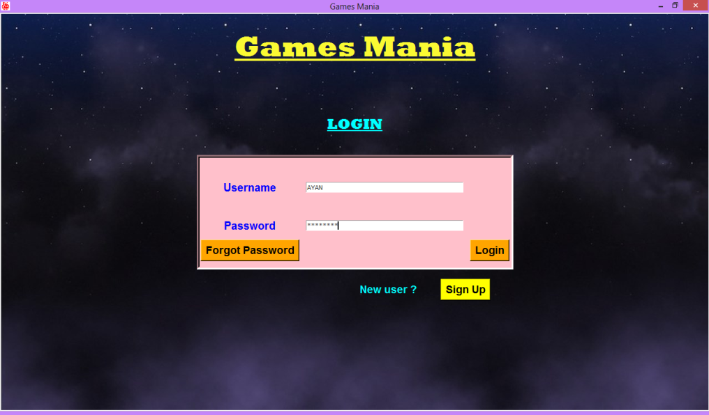# This is the main window consisting of login and sign up options.

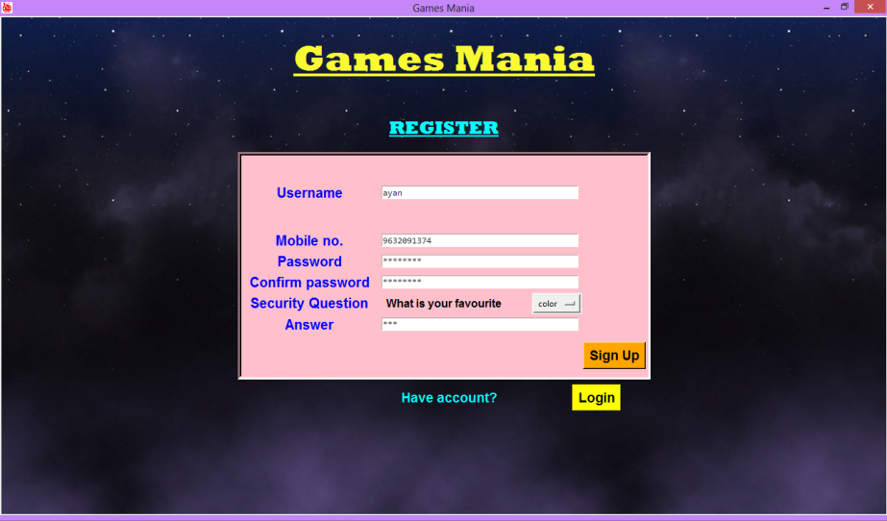# This is the Sign Up (Register account) page.

# If you forgot your password, then this appears when you click on Forgot Password button on login page.

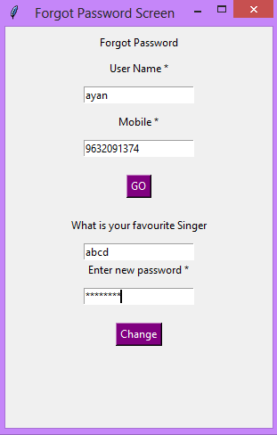

# After clicking on change, your new password will be set and this dialogue box appears

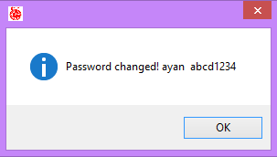

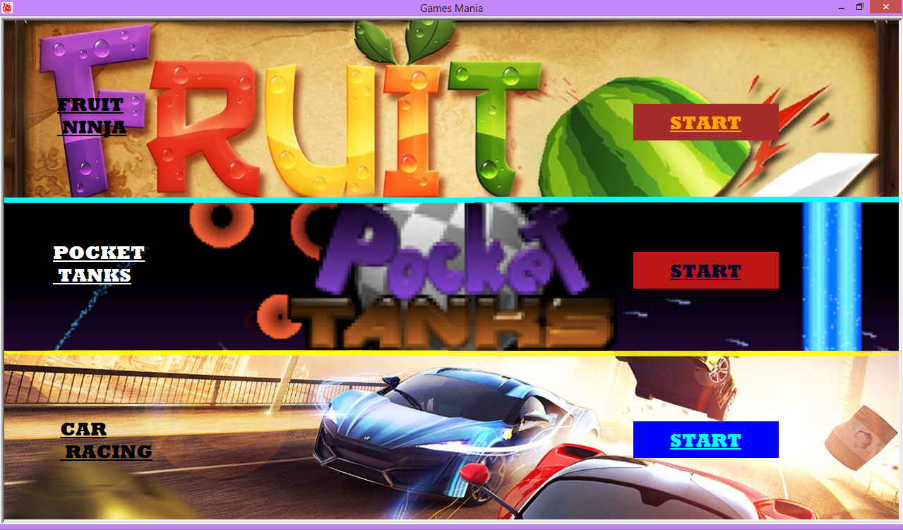# This is the main Menu page after logging in.

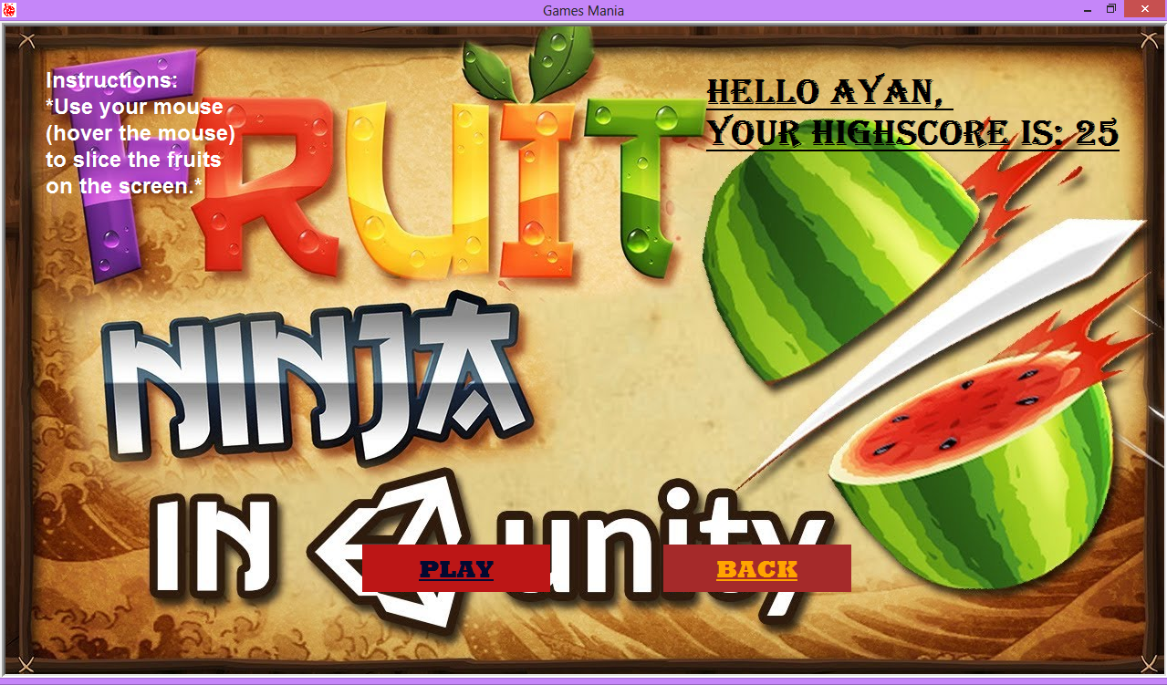# After clicking on start button of the Fruit Ninja game, this window appears.

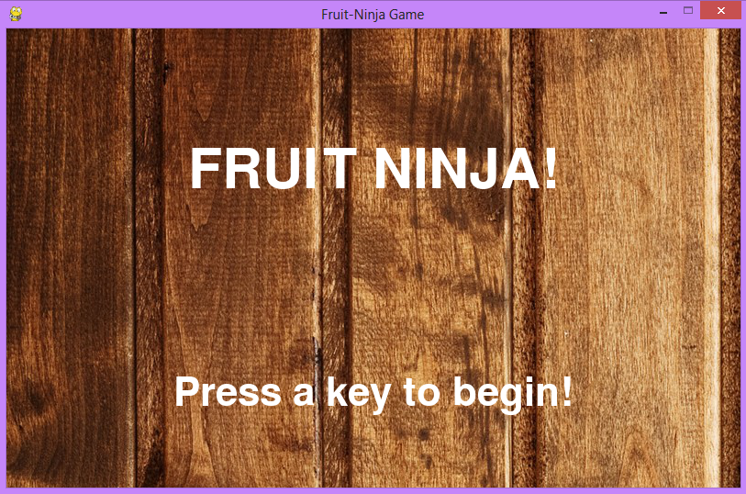# When you click on Play button, this window appears.

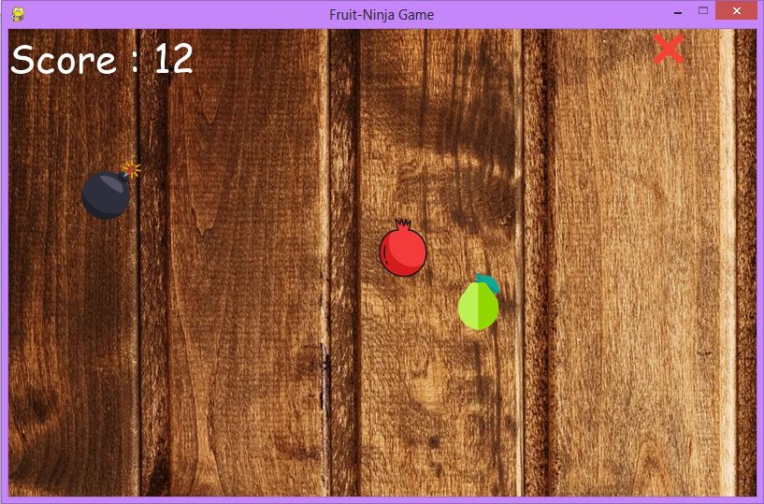# Now after pressing any key, the game will start.

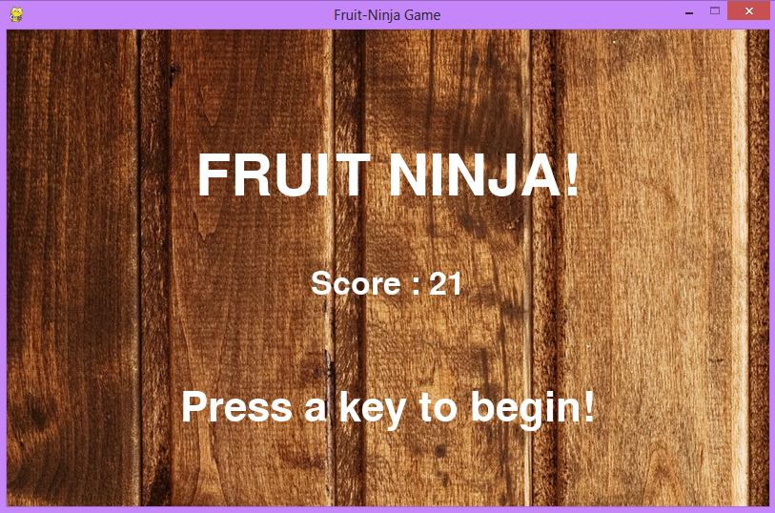# When your game is over, the following screen is shown.

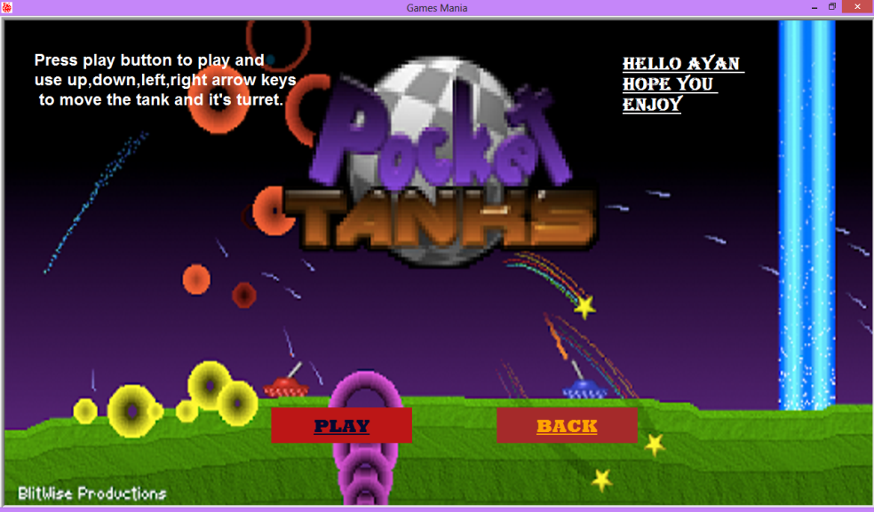# Now, if you click on Start button of the Tanks game on the main menu, this window appears.

# When you click on Play button, this window appears.

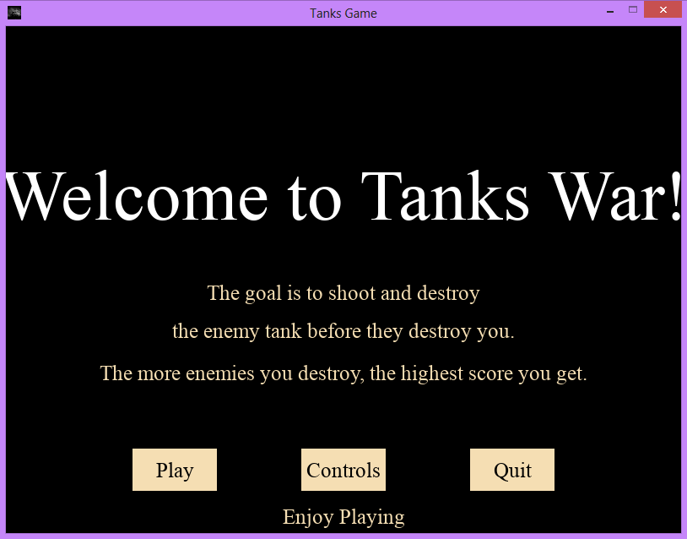

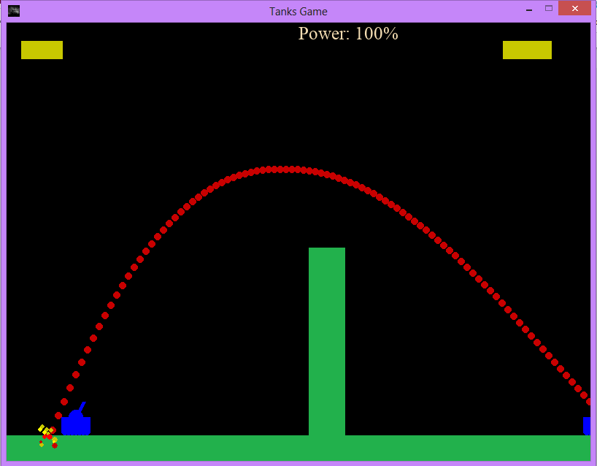# After you click on Play, the game starts and this screen appears.

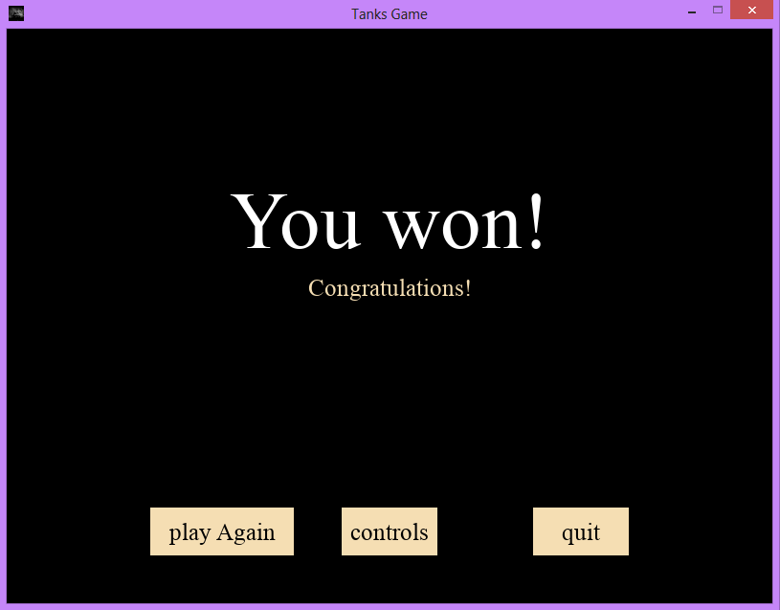# After the game is over, this screen appears.

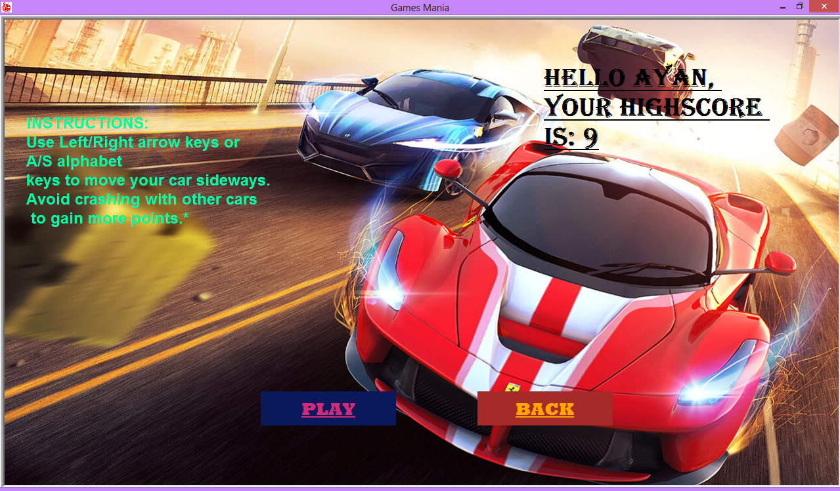# Now, if you click on Start button of the Car Race game on the main menu, this window appears.

# If you click on the Play button, this window appears.

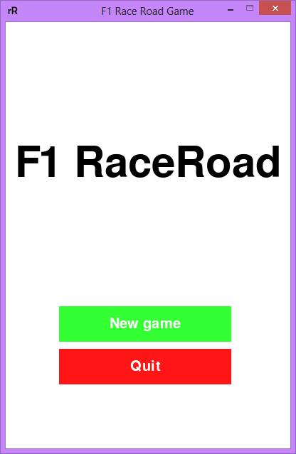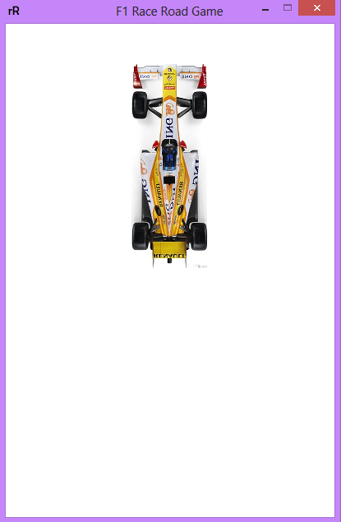

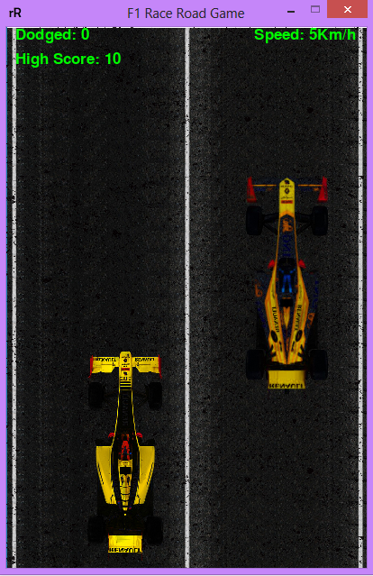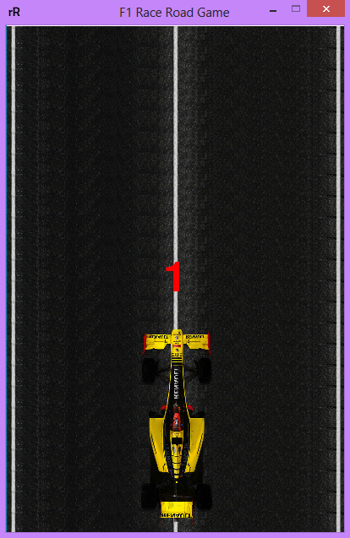# After you click on New game, then this screen appears.

# After the game is over, this screen appears.

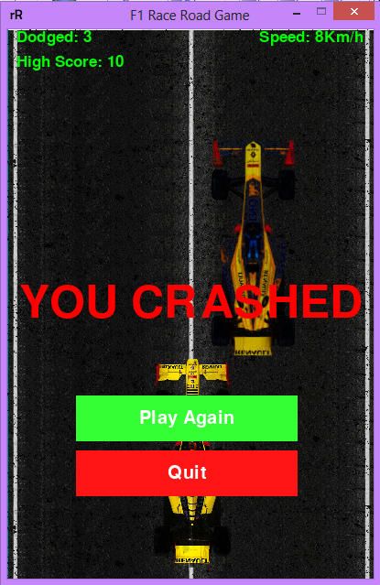

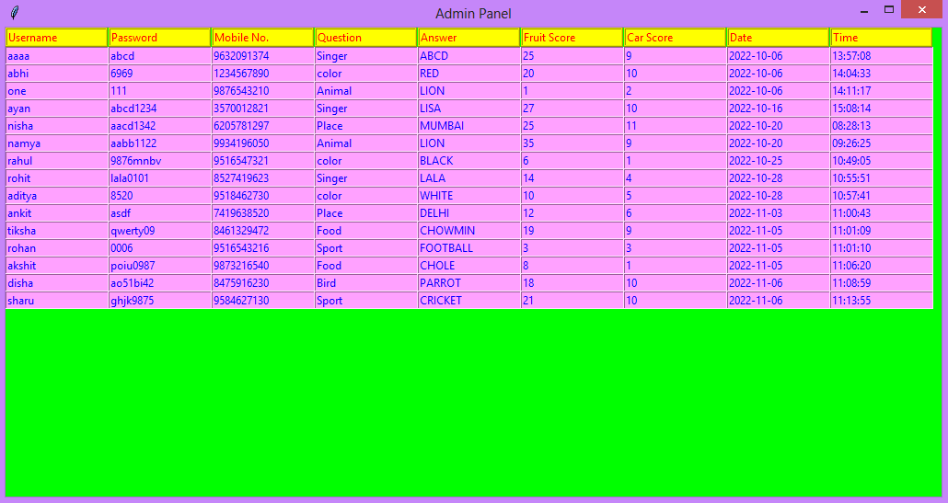# If you log in with admin id at the login page, the following window appears, and details of every user is shown.

COnclusion

This project is on menu driven programme of various Games. This project helped me to know and learn a lot about various libraries in python, how are they working and their applications into different places. It was also a quite fun working with the Tkinter GUI (Graphical User Interface). It was a very interesting project and it made me realize about how much we can learn from computers. Further it cleared our concepts and logic of programming.

Bibliography

* **COMPUTER SCIENCE** with python by **PREETI ARORA.**
* **Python** and **Tkinter** programming by **John E. Grayson.**
* <https://www.google.com>
* <https://www.youtube.com>
* <https://www.github.com>
* <https://www.stackoverflow.com>





